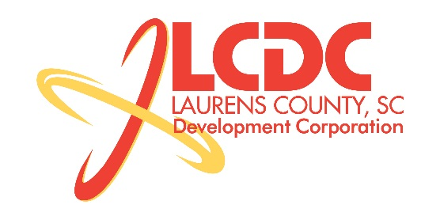
Board Meeting
Tuesday, July 21, 2015
12:00 PM
Laurens County Chamber of Commerce

MEETING AGENDA

- Welcome / Call to Order / Invocation – Stan Bryson
- Approval of Agenda – Stan Bryson
- Approval of 5/19/15 Minutes – Stan Bryson
- Review of May/June Financials & Investor Update – Lynn Finley

Business/Reports

- 2014 Audit Report – Matt Phillips McKinley Cooper
- Existing Industry/Retail Update – Marvin Moss
- Economic Development Update – Marvin Moss
- CEDC Update – Collie Lehn
- Laurens ED Update – John Young
- Upstate Alliance Update – John Lummus
- Review of Land Sale – Marvin Moss
- Project Tundra Addition
- Financial Committee Report – Frank Stovall

Executive Session (if needed)

- Employment Matter
- Legal Briefing on a Contractual Matter

Reconvene Regular Meeting

- Other Business

Adjourn

