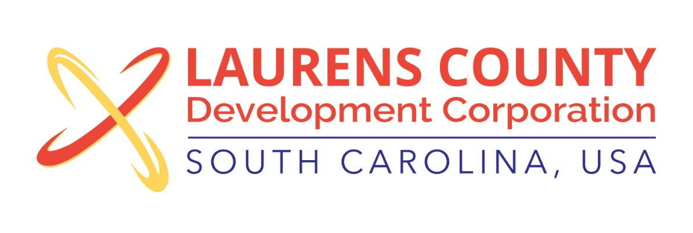
Board Meeting
Tuesday, July 19, 2016
12:00 PM
Laurens County Chamber of Commerce

MEETING AGENDA

- Welcome / Call to Order / Invocation – Stan Bryson
- Approval of Agenda – Stan Bryson
- Approval of 5/17/16 Minutes – Stan Bryson
- Review of May & June Financials – Lynn Finley

Business/Reports

- Review of 2015 Audit - Matt Phillips, McKinley, Cooper & Co., LLC.
- Executive Director’s Report – Jonathan Coleman
- Other Reports

Executive Session (if needed)

Adjourn

