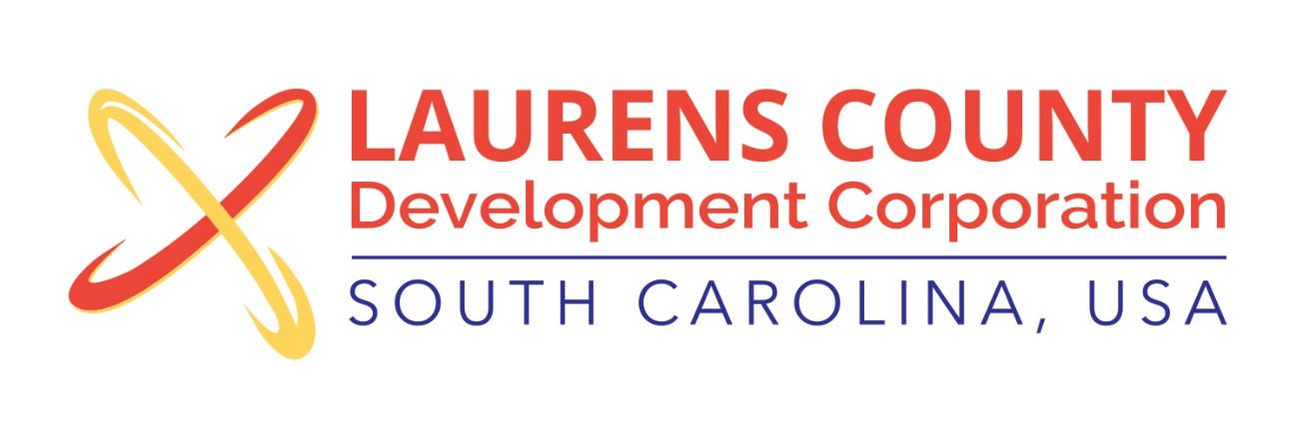
Board Meeting
Tuesday, May 17, 2016
12:00 PM
Laurens County Chamber of Commerce

MEETING AGENDA

- Welcome / Call to Order / Invocation – Stan Bryson
- Approval of Agenda – Stan Bryson
- Approval of 1/19/16 and 3/15/16 Minutes – Stan Bryson
- Review of March/April Financials – Lynn Finley

Business/Reports

- Executive Director’s Report – Jonathan Coleman
- ZF Transmissions Update – Michael Morris, HR Manager, ZF Transmissions
- Other Reports

Executive Session (if needed)

Adjourn

