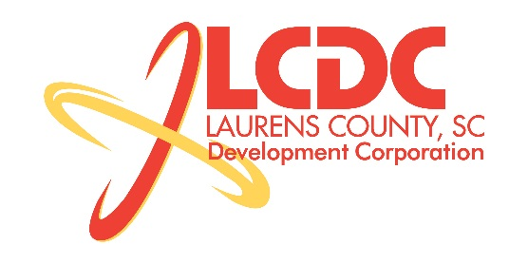
Board Meeting
Tuesday, March 19, 2013
Noon
Laurens County Chamber of Commerce

MEETING AGENDA

- Welcome / Call to Order / Invocation – Jim Coleman
- Approval of Agenda – Jim Coleman
- Approval of 11/13/12 Minutes – Jim Coleman
- Review of Nov/Dec/Jan/Feb Financials – Theresa Gille
- Investor Update – Theresa Gille

Business/Reports

- Workforce Development Update – Theresa Gille
- Economic Development Update – Marvin Moss
- Laurens First Update – Dale Satterfield
- CEDC Update – Collie Lehn
- Financial Committee Update – Randy Garrett
- Upstate SC Alliance Update – Aimee Redick
- Property Acquisition Request – Marvin Moss
- Y Factor Request – Marvin Moss
- Strategic Plan Request – Marvin Moss
- Spec Building Update – Marvin Moss
- Golf Tournament Update – Theresa Gille
- Other Business

Executive Session (if needed)

Adjourn

