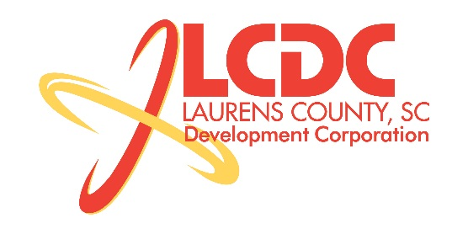
Board Meeting
Tuesday, September 23, 2014
12:00 PM
Laurens County Chamber of Commerce

MEETING AGENDA

- Welcome / Call to Order / Invocation – Jim Coleman
- Approval of Agenda – Jim Coleman
- Approval of 05/20/14 Minutes – Jim Coleman
- Review of July/August Financials & Investor Update – Marvin Moss

Business/Reports

- Existing Industry/Retail Update – Jon Coleman
- Economic Development Update – Marvin Moss
- CEDC Update – Collie Lehn
- Laurens ED Update – John Young
- Upstate Alliance Update – John Lummus
- Owings Park Blvd. Road Transfer – Sandy Cruickshanks
- Laurens Electric Easement – Sandy Cruickshanks
- Project Lambeau Land Sale – Sandy Cruickshanks
- Other Business

Executive Session (if needed)

Adjourn

