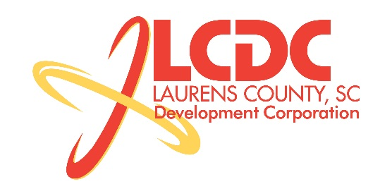
Board Meeting
Tuesday, January 21, 2014
12:00 PM
Laurens County Chamber of Commerce

MEETING AGENDA

- Welcome / Call to Order / Invocation – Jim Coleman
- Approval of Agenda – Jim Coleman
- Approval of 11/19/13 Minutes – Jim Coleman
- Review of Nov/Dec Financials & Investor Update – Theresa Gille

Business/Reports

- Workforce Development – Theresa Gille
- Existing Industry/Retail Update – Jon Coleman
- Economic Development Update – Marvin Moss
- CEDC Update – Collie Lehn
- Laurens First Update – Dale Satterfield
- Upstate Alliance Update – Clay Andrews
- Retail Presentation – Matt Petro, Retail Strategies
- Owing Industrial Park Water & Sewer Project – Marvin Moss
- Other business

Executive Session (if needed)

Adjourn

