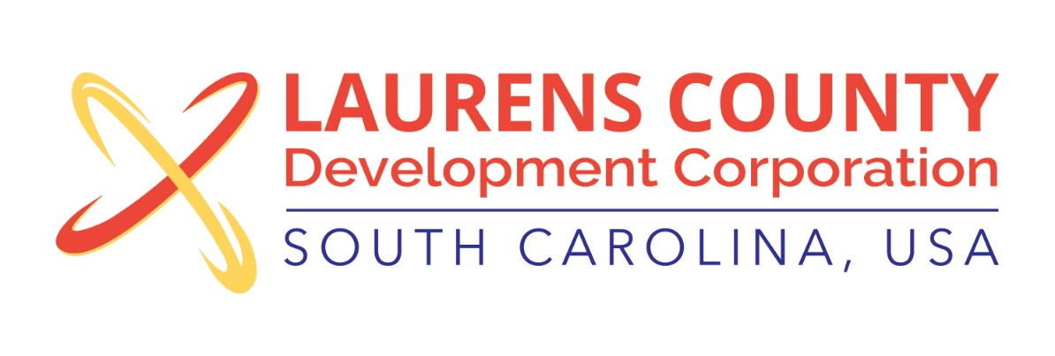
Board Meeting
Tuesday, November 20, 2018
12:00 PM
Laurens County Chamber of Commerce

MEETING AGENDA

- Welcome / Call to Order / Invocation – Jeff Field
- Approval of Agenda – Jeff Field
- Approval of 9/11/18 Minutes – Jeff Field
- Review of September & October 2018 Financials – Lynn Finley

Business/Reports

- Prospect Activity Report – Jonathan Coleman
- Product Development Update – Jonathan Coleman
- Industry & Workforce Dev. Update – Lynn Finley
- 2019 Budget Approval – John Young, Treasurer
- 2019-2020 Officer Election – Stan Bryson, Nominating Committee Chair
- Annual Meeting – Jonathan Coleman
- Other Reports

Executive Session (if needed)

Adjourn

