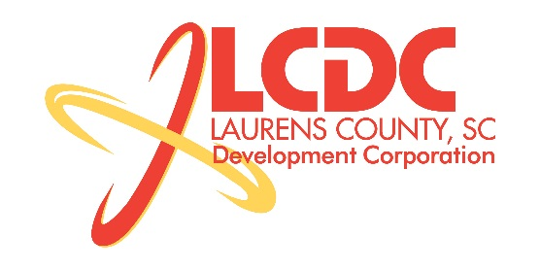
Board Meeting
Tuesday, July 16, 2013
11:30am
Laurens County Chamber of Commerce

MEETING AGENDA

- Welcome / Call to Order / Invocation – Jim Coleman
- Approval of Agenda – Jim Coleman
- 2013 Strategic Plan Overview – Marvin Moss
- Approval of 5/21/13 Minutes – Jim Coleman
- Review of May & June Financials – Theresa Gille

Business/Reports

- Overview of 2012 Audit – Toni McKinley
- Existing Industry/Retail Update – Jon Coleman
- Economic Development Update – Marvin Moss
- Laurens First Update – Dale Satterfield
- CEDC Update – Collie Lehn
- Spec Building Update – Marvin Moss
- Other Business

Executive Session (if needed)

Adjourn

