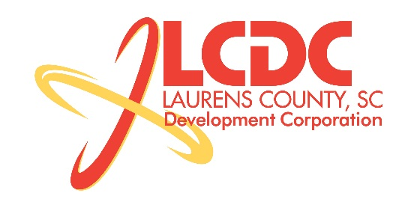
Board Meeting
Tuesday, November 19, 2013
12:00 PM
Laurens County Chamber of Commerce

MEETING AGENDA

- Welcome / Call to Order / Invocation – Jim Coleman
- Approval of Agenda – Jim Coleman
- Approval of 9/17/13 Minutes – Jim Coleman
- Review of Sept./Oct. Financials & Investor Update – Theresa Gille

Business/Reports

- Workforce Development – Theresa Gille
- Existing Industry/Retail Update – Jon Coleman
- Economic Development Update – Marvin Moss
- CEDC Update – Collie Lehn
- Laurens First Update – Dale Satterfield
- Upstate Alliance Update – Hal Johnson
- Owing Industrial Park Water & Sewer Project – Marvin Moss
- 2014 Budget Proposal – Randy Garrett
- Proposed Spec Building Request – Dale Satterfield & Frank Stovall
- Other business

Executive Session (if needed)

Adjourn

