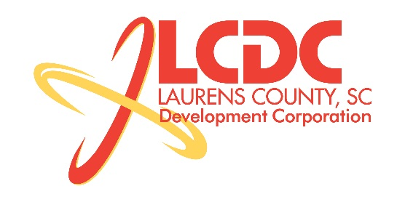
Board Meeting
Tuesday, November 18, 2014
12:00 PM
Laurens County Chamber of Commerce

MEETING AGENDA

- Welcome / Call to Order / Invocation – Jim Coleman
- Approval of Agenda – Jim Coleman
- Approval of 09/23/14 Minutes – Jim Coleman
- Review of September/October Financials & Investor Update – Lynn Finley

Business/Reports

- Existing Industry/Retail Update – Jon Coleman
- Economic Development Update – Marvin Moss
- CEDC Update – Collie Lehn
- Laurens ED Update – John Young
- Upstate Alliance Update – John Lummus
- 2015 Budget – Randy Garrett
- Appointment of Officer Selection Committee – Jim Coleman
- Other Business

Executive Session (if needed)

Employment Matter

Adjourn

