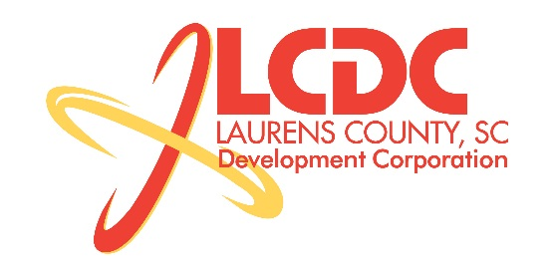
Board Meeting
Tuesday, July 15, 2014
12:00 PM
Laurens County Chamber of Commerce

MEETING AGENDA

- Welcome / Call to Order / Invocation – Jim Coleman
- Approval of Agenda – Jim Coleman
- Approval of 05/20/14 Minutes – Jim Coleman
- Review of May/Jun Financials & Investor Update – Marvin Moss

Business/Reports

- Financial Audit Results – McKinley Cooper
- Existing Industry/Retail Update – Jon Coleman
- Economic Development Update – Marvin Moss
- CEDC Update – Collie Lehn
- Laurens First Update – John Young
- Upstate Alliance Update – John Lummus
- Financial-Business Manager Update – Marvin Moss
- Other business

Executive Session

Economic Development matter

Adjourn

