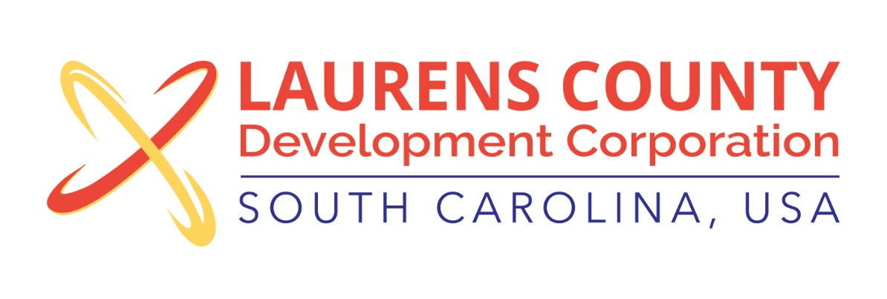
Board Meeting
Tuesday, July 25, 2017
12:00 PM
Laurens County Chamber of Commerce

MEETING AGENDA

- Welcome / Call to Order / Invocation – Jeff Field
- Approval of Agenda – Jeff Field
- Approval of 5/16/17 Minutes – Jeff Field
- Review of May & June 2017 Financials – Lynn Finley

Business/Reports

- 2016 Annual Audit – Matt Phillips, McKinley Cooper
- Bylaw Update – Jeff Field
- Executive Director’s Report – Jonathan Coleman
- Business and Education Partnership – Lynn Finley
- Laurens District 55 Presentation – Dr. Stephen Peters
- Other Reports

Executive Session (if needed)

Adjourn

