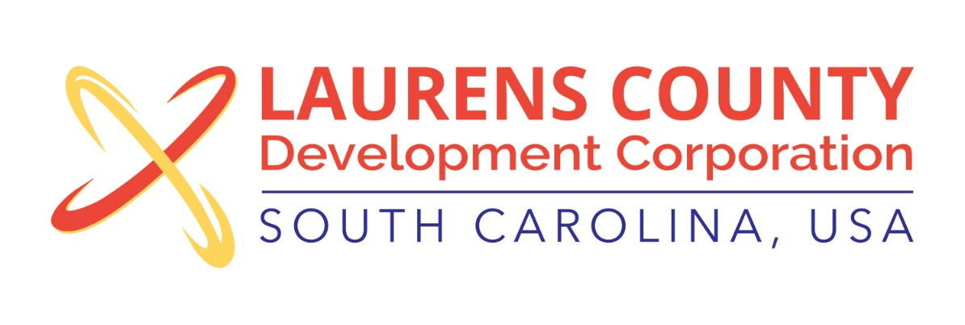
Board Meeting
Tuesday, March 20, 2018
12:00 PM
Laurens County Chamber of Commerce

MEETING AGENDA

- Welcome / Call to Order / Invocation – Jeff Field
- Approval of Agenda – Jeff Field
- Approval of 11/21/17 Minutes – Jeff Field
- Review of December 2017, January & February 2018 Financials – Lynn Finley

Business/Reports

- Executive Director’s Report – Jonathan Coleman
- Higher Opportunity Initiative – Jonathan Coleman & Whitney Robertson
- Business and Education Partnership – Lynn Finley
- Executive Session (Economic Development Matter)
- The Connexial Center – Jonathan Coleman
- Octagon Reinvestment Funds Approval – Jeff Field and Jonathan Coleman

Adjourn

