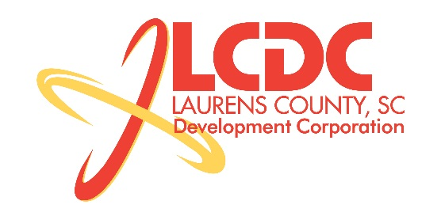
Board Meeting
Tuesday, September 17, 2013
12:00 PM
Laurens County Chamber of Commerce

MEETING AGENDA

- Welcome / Call to Order / Invocation – Jim Coleman
- Approval of Agenda – Jim Coleman
- Approval of 7/16/13 Minutes – Jim Coleman
- Review of July and August Financials & Investor Update – Theresa Gille

Business/Reports

- Executive Committee Recommendation – Jim Coleman
- Workforce Development – Theresa Gille/Jon Coleman
- Existing Industry/Retail Update – Jon Coleman
- Economic Development Update – Marvin Moss
- CEDC Update – Collie Lehn
- Laurens First Update – Dale Satterfield
- Upstate Alliance Update – Hal Johnson
- Spec Building Update & Insurance Coverage – Marvin Moss

Executive Session (if needed)

Adjourn

