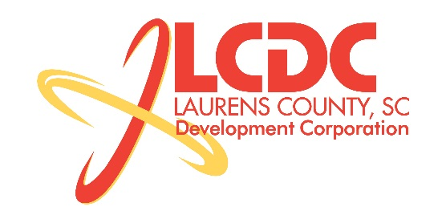
Board Meeting
Tuesday, September 15, 2015
12:00 PM
Laurens County Memorial Hospital

MEETING AGENDA

- Welcome / Call to Order / Invocation – Stan Bryson
- Approval of Agenda – Stan Bryson
- Approval of 7/21/15 Minutes – Stan Bryson
- Review of July/August Financials & Investor Update – Lynn Finley

Business/Reports

- Existing Industry/Retail Update – Jon Coleman
- Economic Development Update – Marvin Moss
- CEDC Update – Frank Stovall
- Laurens ED Update – John Young
- Upstate Alliance Update – John Lummus
- Sale of Property – Marvin Moss
- Finance Committee Update – Frank Stovall

Executive Session (if needed)

- Employment Matter

Reconvene Regular Meeting

- Other Business

Adjourn

