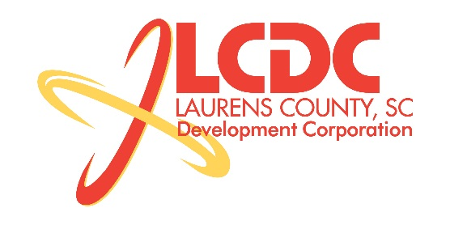
Board Meeting
Tuesday, May 21, 2013
Noon
Laurens County Chamber of Commerce

MEETING AGENDA

- Welcome / Call to Order / Invocation – Jim Coleman
- Approval of Agenda – Jim Coleman
- Approval of 3/19/13 Minutes – Jim Coleman
- Review of March & April Financials – Theresa Gille
- Investor Update – Theresa Gille

Business/Reports

- Workforce Development Update – Theresa Gille
- Existing Industry/Retail Update – Jon Coleman
- Economic Development Update – Marvin Moss
- Laurens First Update – Dale Satterfield
- CEDC Update – Collie Lehn
- Financial Committee Update – Randy Garrett
- Strategic Plan Update – Jon Coleman
- Spec Building Update – Marvin Moss
- Other Business

Executive Session (if needed)

Adjourn

