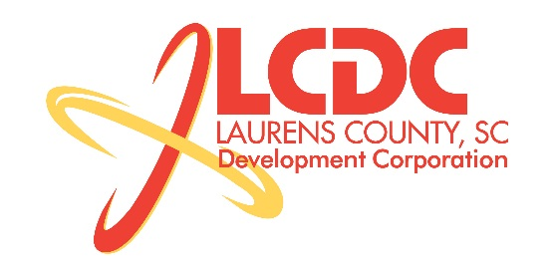
Board Meeting
Tuesday, January 20, 2015
12:00 PM
Laurens County Chamber of Commerce

MEETING AGENDA

- Welcome / Call to Order / Invocation – Jeff Field
- Approval of Agenda – Jeff Field
- Approval of 11/18/14 Minutes – Jeff Field
- Review of November/December Financials & Investor Update – Lynn Finley

Business/Reports

- Existing Industry/Retail Update – Jon Coleman
- Economic Development Update – Marvin Moss
- CEDC Update – Collie Lehn
- Laurens ED Update – John Young
- Upstate Alliance Update – John Lummus
- Review/approval of By-Laws – Jeff Field
- Approval of 2015 Officers – Greg Alexander

Executive Session (if needed)

Adjourn

