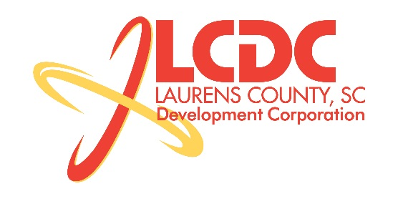
Board Meeting
Tuesday, March 18, 2014
12:00 PM
Laurens County Chamber of Commerce

MEETING AGENDA

- Welcome / Call to Order / Invocation – Jim Coleman
- Approval of Agenda – Jim Coleman
- Approval of 01/21/14 Minutes – Jim Coleman
- Review of Jan/Feb Financials & Investor Update – Theresa Gille

Business/Reports

- Laurens County Museum – Faye Edge & Ernie Segars
- Workforce Development – Theresa Gille
- Existing Industry/Retail Update – Jon Coleman
- Economic Development Update – Marvin Moss
- CEDC Update – Collie Lehn
- Laurens First Update – John Young
- Upstate Alliance Update – Clay Andrews
- LCWSC Right-of-way Resolution – Marvin Moss
- Project Tablet Resolution – Marvin Moss
- Other business

Executive Session (if needed)

Adjourn

