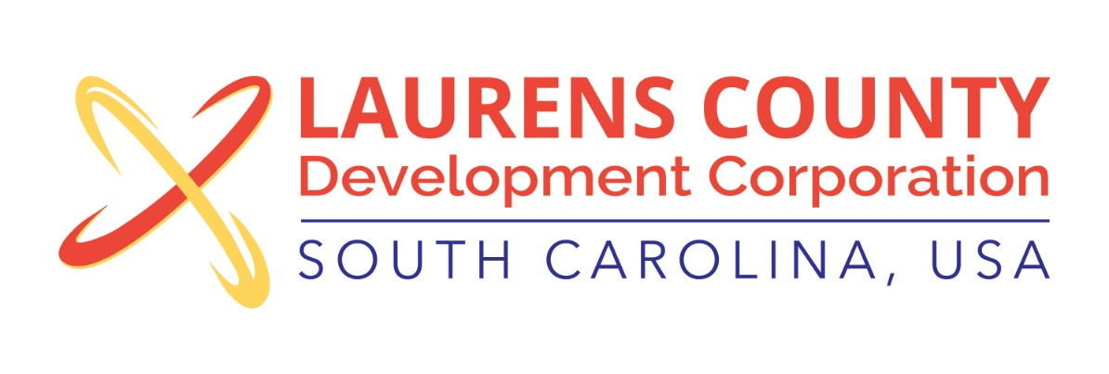
Board Meeting
Tuesday, March 21, 2017
12:00 PM
Laurens County Chamber of Commerce

MEETING AGENDA

- Welcome / Call to Order / Invocation – Jeff Field
- Approval of Agenda – Jeff Field
- Approval of 11/8/16 Minutes – Jeff Field
- Review of December 2016 and January - February 2017 Financials – Lynn Finley

Business/Reports

- Executive Director’s Report – Jonathan Coleman
- Business and Education Partnership – Lynn Finley
- Laurens County Branding Initiative – Jon Caime
- Other Reports

Executive Session (if needed)

Adjourn

