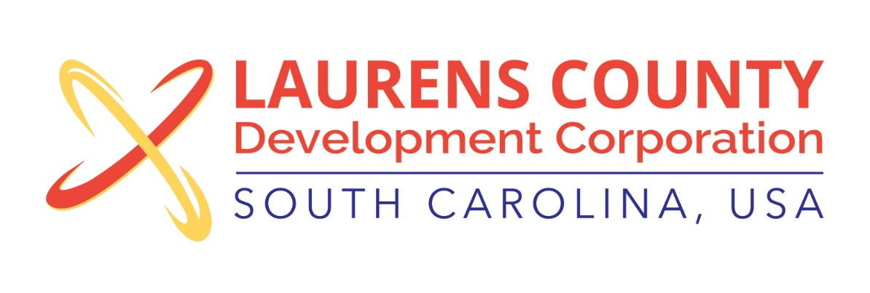
Board Meeting
Tuesday, May 16, 2017
12:00 PM
Laurens County Chamber of Commerce

MEETING AGENDA

- Welcome / Call to Order / Invocation – Jeff Field
- Approval of Agenda – Jeff Field
- Approval of 3/21/17 Minutes – Jeff Field
- Review of March & April 2017 Financials – Lynn Finley

Business/Reports

- Executive Director’s Report – Jonathan Coleman
- Business and Education Partnership – Lynn Finley
- Nomination for Treasurer – Stan Bryson
- ZF Apprenticeship Update – Robbie Ellis, ZF Transmissions
- Other Reports

Executive Session (if needed)

Adjourn

